📊 Comprehensive Dataset Collection from AICTE
Team Members:
- Yogendra Bhange
- Yash Dudhe

- Project Overview
This project focuses on automated scraping, cleaning, and conversion of structured education data from the official AICTE Dashboard. It extracts detailed institute and course information across Pharmacy, Engineering & Technology, and Applied Arts & Crafts programs.

- Folder Structure
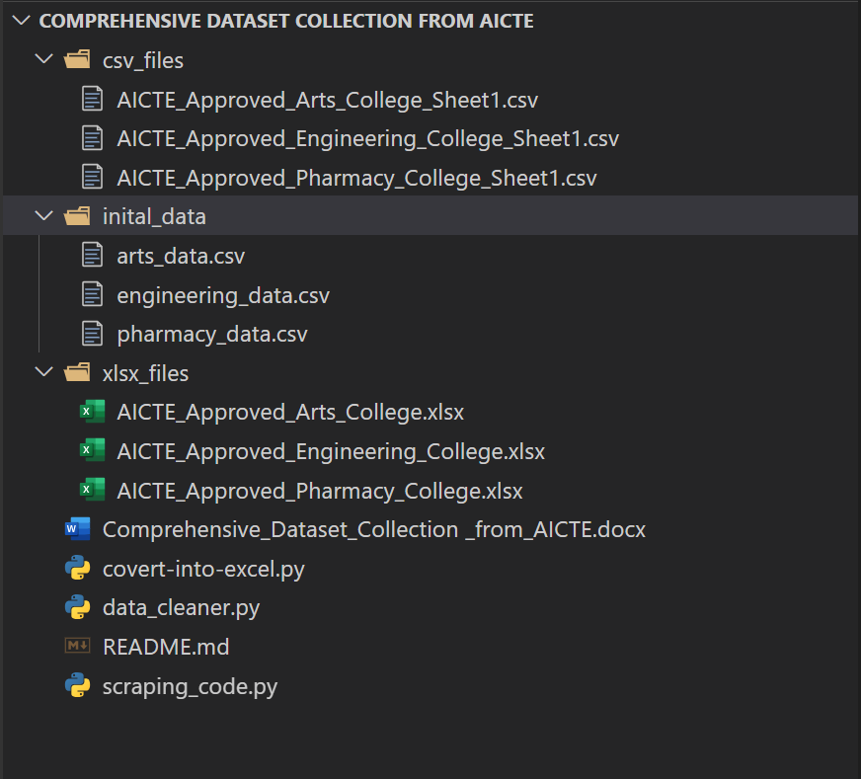

- Functional Modules
1. scraping_code.py
- Scrapes all AICTE approved institute data using Selenium.
- Fields include:
  - Year, State, Program, Level
  - Institute name, address, city, type
  - University, accreditation, approval year
  - Course details (via "Click Here" popups) — Intake and Offered Course.
2. data_cleaner.py
- Cleans unwanted columns like “Click Here” texts.
- Removes NA/empty rows.
- Saves clean version into cleaned_data/.
3. covert-into-excel.py
- Converts cleaned .csv files into .xlsx format.
- Output saved in xlsx_files/.

📥 Input Source
All data was scraped from the official AICTE Dashboard:
https://facilities.aicte-india.org/dashboard/pages/angulardashboard.php#!/approved

- Output Summary
Program | Original CSV | Cleaned CSV | Final Excel
Pharmacy | pharmacy_data.csv | pharmacy_cleaned.csv | pharmacy_cleaned.xlsx
Engineering & Tech | engineering_data.csv | engineering_cleaned.csv | engineering_cleaned.xlsx
Applied Arts & Crafts | arts_data.csv | arts_cleaned.csv | arts_cleaned.xlsx

- Output Storage
- ✅ .csv files → stored in cleaned_data/
- ✅ .xlsx files → stored in xlsx_files/
- 📄 Documentation → Comprehensive_Dataset_Collection.docx

📌 Conclusion
The project efficiently demonstrates automated web scraping, data cleaning, and Excel conversion using Python. It can be scaled or adapted for other government/educational dashboards in the future.

